Dear Friends,

Spring is finally here, bringing exciting updates and celebrations at Lighthouse of Broward! The past few months have been filled with incredible events, new opportunities, and inspiring moments—all made possible by our amazing community.

We recently hosted a hugely successful Client Resource Fair at Flamingo Hall, bringing together over 15 vendors, volunteers, staff, and over 100 attendees for an unforgettable day of connection and empowerment. The event was a true testament to the support available for our blind and visually impaired community. We are so grateful to everyone who made this event such a success!

We are also gearing up for one of our favorite annual traditions, the Heroes Benefit Concert in partnership with American Heritage Schools! This marks our fifth consecutive year of working together to bring an inspiring night of music and celebration to our community. This year’s theme is ‘50s Prom Night, promising a fun, nostalgic evening filled with incredible performances. We are so grateful to American Heritage for their continued support, and we can’t wait to see you there on May 3rd!
Beyond the concert, we are incredibly proud to share that American Heritage students competed at a national robotics competition and won 2nd place! But what makes this achievement even more incredible is that they were honored with the National Community Impact Award for their work with our blind and visually impaired students. This prestigious award recognizes their dedication to making robotics education accessible and inclusive—an achievement that truly sets them apart. We couldn’t be more thrilled to celebrate their innovation and impact, and we look forward to continuing this incredible partnership!

We’re also thrilled to announce the expansion of our Assistive Technology team! Please join us in welcoming Jose Cintron, our new AT Instructor, who brings over a decade of experience in assistive technology. Additionally, we are excited to introduce Shurri Dixon as our new Keyboarding Instructor, who has extensive experience working with visually impaired individuals. Also, we have Austin Philipson joining us as our new Technology Assistant who brings experience in teaching. We know they will make a significant impact on our community!

Client Spotlight: Romario Blake’s Journey of Resilience and Success

At Lighthouse of Broward, we witness inspiring stories of determination every day, and Romario Blake’s journey is one that truly stands out.
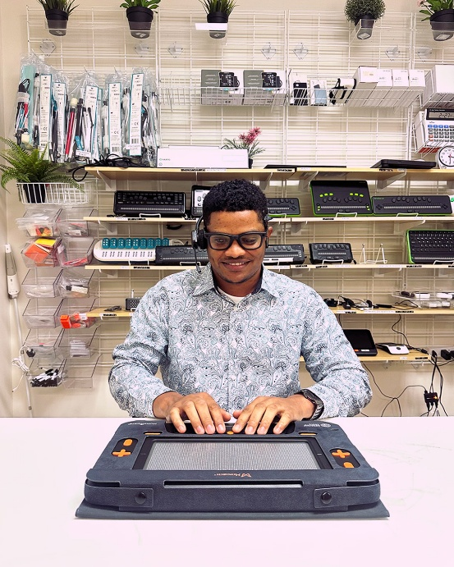
Losing his vision at 24 was life-altering, but when someone at the mall noticed his cane and introduced him to Lighthouse of Broward, his journey of rehabilitation and career development began.

Romario’s first work experience was with Heart to Heart, a nonprofit serving elderly individuals. While he gained valuable skills as an administrative assistant, he was still exploring different career paths. His biggest challenge was overcoming self-doubt, but with encouragement from his job coach, Rebecca Feingold, and supportive colleagues, he was reminded of his strength and capabilities.

It was a timely connection with Florida Vision Technology that set him on a fulfilling path. With his background in technology and community involvement, serving on the National Federation of the Blind’s board, participating in BELL (Braille Enrichment for Literacy and Learning) Challenges, and playing on the Braille Bandits baseball team, Romario was a perfect match for the role.

After completing an 8–10 week work experience, Romario was offered a permanent position as a Blindness Sales and Training Specialist at Florida Vision Technology. Today, he helps clients find the right assistive technology, trains them on its use, and travels to industry events across Florida to promote the latest innovations.

Romario’s journey is a powerful reminder of how support, resilience, and opportunity can open doors to new possibilities. We are incredibly proud of him and excited for what’s ahead!

We look forward to an incredible season ahead, filled with growth, empowerment, and success!

Ellyn Drotzer, MSW, LCSW
President and CEO

Important Notice: Facility Renovations in the Coming Months

Our facility will be undergoing renovations in the coming months. To stay informed about any temporary changes to service locations, social activities, and potential building closures, please contact us directly or visit our website for real-time updates.
Call the front desk at 954-463-4217 (Dial 0) or visit www.lhob.org for the latest information.
Thank you for your understanding and support!

Important Building Closure Dates & Updates
• LHOB Closed for Memorial Day, Monday May 26, 2025.
• LHOB Closed for Juneteenth, Thursday June 19th, 2025.

LHOB Social Groups and Activities: For all events you must RSVP in advance as space is limited.

Zumba Class: Every Friday from 12:30p.m. – 1:30p.m. except May 2nd. Join us for a fun and energetic Zumba class that combines dance and fitness! This class features high-energy music and dynamic dance moves that provide an excellent cardio workout while improving coordination and rhythm. While most of the movements can be adapted for a seated position, there will also be some standing routines to elevate your heart rate and boost your mood. Whether you’re a seasoned dancer or a beginner, this class is designed for everyone to enjoy! Please RSVP at 954-463-4217 ext. 110. Space is limited.

Arts & Crafts: Every Thursday from 1:00p.m. – 3:00p.m. except June 12th, June 19th, and June 26th. Join us for adapted arts and crafts projects including painting with tactile lines, clay work, sewing, and floral arrangements. Activities vary each week. Please RSVP at 954-463-4217 ext. 110. Space is limited.

Book Club will meet on the last Friday of every month from 10:00 a.m. – 12:00 p.m. For more information, please contact the front desk at 954-463-4217 ext. 110. Space is limited, you must RSVP.

April 25th – The Moores Are Missing, by James Patterson, 10.32, Mystery Fiction, DB 117951

May 30th – A Calamity of Souls, by David Baldacci, 14.32, Legal Fiction, DB 120798

June 27th – The Last Sinner, by Lisa Jackson, 17.21, Mystery Fiction, DB 120808

Trivia Group: April 4th and May 9th from 10:00am-12:00pm. When raucous laughter is heard in the halls of the Lighthouse, you can be sure it’s coming from the trivia group. Questions on a variety of subjects are read by a volunteer, and anyone who thinks they have the answer is free to call it out. Please RSVP at 954-463-4217 ext. 110. Space is limited.

BINGO: April 11th & 18th and May 16th & 23rd from 10:00 a.m. – 12:00 p.m. Join us for Bingo with Brailed cards and large print cards. There are prizes for the winners. Please RSVP at 954-463-4217 ext. 110. Space is limited.

In-Person Problem Solvers Support Group for past clients with Dr. Alan Katell: Thursday, April 10th, May 8th, and June 12th from 11:00am – 12:00pm. This support group offers a space for past clients to connect with others who have similar experiences. Instructors lead discussions on relevant topics and challenges that members with visual impairments may be encountering. This group provides an opportunity for individuals to share their experiences, insights, and strategies, fostering a supportive environment where members can exchange ideas, offer mutual encouragement, and work together to find effective solutions. Please RSVP at 954-463-4217 ext. 110. Space is limited.

Descriptive movies: Join us on select Thursdays for a movie, popcorn, and treats. The movies will be shown in Classroom Two from 10:00am – 12:00pm. Please RSVP at 954-463-4217 ext. 110. Space is limited.

April 3rd – After Earth (English): After crash-landing on the long-abandoned planet Earth, a young boy sets out to find a beacon that will save him -- and his dying father -- from doom.

April 17th – Thunder Force (Spanish): Two childhood best friends reunite as an unlikely crime-fighting superhero duo when one invents a formula that gives ordinary people superpowers.

May 1st – 80 for Brady (English): Four longtime friends embark on a rollicking adventure after scoring tickets to see their favorite star quarterback — Tom Brady — play in the Super Bowl.

May 15th – We Have a Ghost (Spanish): After finding a ghost with a murky past haunting their new house, a family becomes internet sensations — and the targets of a shadowy government agency.

June 5th – From Prada to Nada (English): Two spoiled sisters who have been left penniless after their father's sudden death are forced to move in with their estranged aunt in East Los Angeles.

*Dates, time, and location of social activities are subject to change please visit our website at www.lhob.org/publications or call our activities line at 954-463-4217 ext. 8 for Up-To-Date information on social activities and meetings. *

Support for Past and Present LHOB Clients:
Last Wednesday of the month (April 30th, May 28th, June 25th) from 1:00-2:00. This support group is to help participants who want to connect with other individuals who are visually impaired. Instructors will discuss strategies for dealing with stress and anxiety. Members of this group can connect; share their experiences, coping strategies, and their strength and hope.
Join the call: https://www.uberconference.com/room/lhobsupport
Optional dial-in number: 954-451-0380
No PIN needed.
International Access Numbers:
https://www.uberconference.com/international
Special Events for Past and Current LHOB Clients:
Talent Show Auditions: Wednesday, April 2nd from 9:00am – 12:00pm. Auditions are open to singers, dancers, comedians, and more. Each audition slot is 20 minutes long. The talent show will take place on May 2nd at our Client Appreciation Lunch. Those chosen will be contacted after the auditions. You must sign up for a time slot. Please sign up by March 28th to Carrie McKenna at 954-463-4217 ext. 138. Space is limited.
Client Appreciation Lunch: Friday, May 2nd from 10:30am – 1:30pm at Flamingo Hall (12855 NW 8th St., Sunrise, FL 33323). There will be a talent show, awards, and music. Lunch is included. Fried Chicken, Green Beans, Potato Salad, Rolls, and Bottled Water or veggie plate without chicken. We unfortunately cannot accommodate substitutions. Wear your denim, boots, and western wear. RSVP by April 18th to the Front Desk at 954-463-4217 ext. 110. Space is limited.

